|  |  |
| --- | --- |
|  | Sussex NHS Foundation Trust | Peoplesafe |

**A Memorandum of Understanding between the Sussex Voluntary, Community and Social Enterprise (‘VCSE’ Sector) in Sussex and the Sussex Health and Care Partnership**

**Statement of intent**

This Memorandum of Understanding (**MOU)** sets out a commitment and framework between Voluntary, community and social enterprise sector and NHS, Sussex that underpins new ways of working and approaches between our sectors that encourages and stimulates innovation, integration and collaboration to collectively improve outcomes for the 1.7 million people who live in Sussex.

It builds on our partnership working and dynamic relationships, committing resources, energy and passion to integrate working **by putting people in our communities at the heart of our shared approach** to achieve our collective aims and objectives as equitable partners.

This MOU includes the guiding principles and culture required to recognise and integrate the VCSE as a system partner, noting the respective roles and boundaries of our sectors and how this connects to local structures and arrangements.

**Scope**

The parties to this Memorandum of Understanding are:

* The partners of the Sussex Health and Care Integrated Care Board
* The Sussex voluntary, community and social enterprise sector Leaders Alliance

This is a live document and its spirit and intention recognises the multi -layers of the integrated system and is intended to sit alongside and complement existing agreements. Equally its scope can evolve and extend to include other organisations over time as appropriate.

**Context**

This memorandum of understanding should be read alongside **‘Delivering Improving Lives together - a Commissioning Framework’ .**

The commissioning framework outlines what the VCSE Sector and Health and Care Partners in Sussex have committed to achieving together, and why and how.

This Memorandum of Understanding sets out the agreed set of responsibilities for all parties in order that we deliver on these commitments.

**Our values**

‘Delivering Improving Lives together - a Commissioning Framework’ sets out the agreed, shared values of the VCSE and Health and Care Sector in Sussex. They can be summarised as follows:

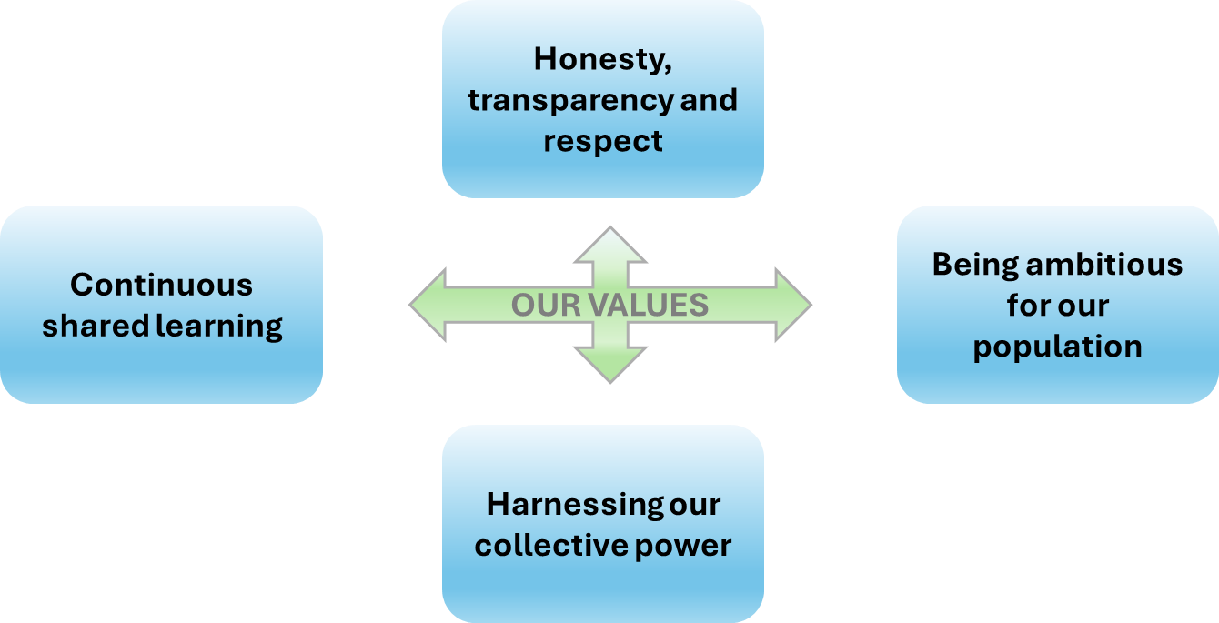

**Our principles**

‘Delivering Improving Lives together - a Commissioning Framework’ is based around 5 agreed principles. These can be summarised as follows.

Health and Care Partners and the VCSE Sector in Sussex will:

**Principle 1. Working together in new ways**

**This Means:**

Leaders from the **VCSE** and **Health and Care** Sectors working together to make the best use of resources in order to improve outcomes for the population of Sussex

**Joint Responsibilities**

* Our system leaders will create and maintain a commitment to working differently together, ensuring the spirit and culture set out in this memorandum of understanding is embedded across our sectors regularly reviewing our progress and the maturity of our working relationship.

**Responsibilities of Health and Care Partners:**

* We will recognise where resources and capacity constraint may impact our VCSE partners and seek to understand and enable collaboration in ways which is sensitive to those constraints.

**Responsibilities of the Sussex VCSE Leaders’ Alliance:**

* Wewill prioritise areas of our strategic engagement with the ICS based on VCSE capacity, and mutual agreement.
* We will work and collaborate within the VCSE sector at all levels of the system to build on existing VCSE structures, creating open and collaborative communication pathways and structures to ensure the development of the VCSE role as a strategic partner within the new health and care structures.

**Principle 2. Transparent and collaborative commissioning**

**This means:**

Taking **shared responsibility** for ensuring that the limited resources we have deliver the best outcomes for the population of Sussex.

**Responsibilities of Health and Care Partners:**

* We will ensure that VCSE is appropriately represented within key decision-making boards and groups at all levels of the system and is a key partner in developing the new health and care structures.
* We will work together with the VCSE and with existing place-based alliances to understand how we can better share insight, intelligence and data across our sectors throughout strategic commissioning and decommissioning planning and service delivery and appropriate, with agreements that are meaningful to both sectors.

**Responsibilities of the Sussex VCSE Leaders’ Alliance:**

* We will work with integrated care partners to form joint approaches to attract external funding into Sussex.
* We will participate in service design, strategic planning and prioritisation including undertaking commissioned work to support the ICS to involve local communities and communities of interest in the planning and design of services.

**Principle 3. Utilising shared learning**

**This means:**

Drawing on **experience and expertise** from across the VSCE and Health and Care Sectors in order to help ensure that value is added, improvements are sustainable, changes are locally led, and that learning can be transferred.

**Joint Responsibilities**

* We will develop a shared learning culture, investing time in learning about each other's sectors, developing mutual understanding and identifying opportunities to work together to add value.

**Principle 4. Understanding Social Value**

**This means:**

When deciding whether to fund organisation or partnership, we agree on how we assess and understand the **wider social, economic and environmental benefits** they can bring.

**Joint Responsibilities**

* We will work together to support leadership and workforce development across our sectors to develop the VCSE role and their opportunities to deliver services, opening new markets and opportunities for VCSE, removing unnecessary barriers to VCSE participation in service delivery.

**Principle 5. Reducing and eliminating Health Inequalities**

**This means:**

Tackling the **avoidable, unfair and systematic differences in health** that exist between different groups of people in Sussex.

**Joint Responsibilities**

* We commit to fostering a culture of inclusion and diversity as a golden thread that is embedded in all approaches to our joint working.
* We will develop engagement structures and spaces that encourage collaboration, and trust, enabling open and constructive discussions to support joint planning and decision making, giving voice to the VCSE on issues that matter to them and the communities they work with.

This agreement takes effect on **1st November 2024** and shall be reviewed within 6 monthsby the parties.

Signatures

Dr Subo Shanmuganathan Lola Banjoko

**SVLA Chair Deputy Chief Integration & Primary Care Officer and Director**

**of Joint Commissioning, NHS Sussex**