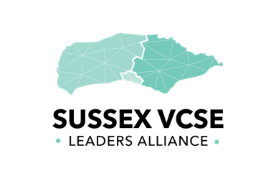
Sussex VCSE Leaders Alliance
SVLA
SVLA Strategic Steering Group Nomination Form
SVLA – Strategic Steering Group

Section A: Your Organisation

A1. Full name of applicant organisation

A2. Organisation’s legal status (You may select more than one box)
Registered Charity
Co-operative
Mutual
Community Interest Company (CIC)
Company Limited by Guarantee
Charity Incorporated Organisation (CIO)
An unincorporated association set up as a voluntary or community group
Faith group engaged in voluntary/social action
Registered Friendly Society
Other
If other please describe
Charity Commission Registration Number*:
Company Registration Number*:
Other Registration Number* (please specify):
VAT Registration Number*:
* If applicable

A3. Nominee name and position in the organisation
Telephone: |  |  | Email:
Do you have any communication needs? |  |  |  |  | Yes No
If yes, what are they?
Please confirm you have support form your board to apply. |  | Yes No
A4. Tell us about your group or organisation
Aims and objectives:

Activities: (please list)

Number of beneficiaries
Number of staff

A5. Financial information
Please select which of the following represents your organisations financial status | £1,000,000 and over
 | £100,000 - £1,000,000
 | £100,000 and under

A6. Geographical Areas of Delivery
East Sussex
West Sussex
Brighton and Hove
Sussex wide

Section B. About you and how you will support the SVLA
B1. Please explain how your experience of supporting diverse groups will help ensure the SVLA Steering Group will have a focus on equality and equity as it works to reduce health inequality. (max 300 words)

B2. Please tell us how you envisage being an active member SVLA Strategic Steering Group
B3. Describe your experience in the VCSE sector and/or health and social care (max 250 words)
B3. What skills and expertise could you bring to the SVLA Steering Group? (max 250 words)

B5. Declaration
I confirm that the information supplied is truthful and accurate and I have authority on behalf of my organisation to make this declaration. I commit to attending meetings and being an active member of the SVLA Strategic Steering Group and will work with partners to work towards reducing health inequities for Sussex.
Signed for and on behalf of the Organisation:
Signed:
Position/Status in the Organisation:
Date:

